* **What is Angular? What are Angular advantages? What the use of Angular?**

Angular is a component-based framework or JavaScript binding framework, which binds HTML UI with JavaScript model for building structured, scalable and single page application for client side with the help of routing.

Advantage:

Relatively simple to build SPA with help of component-based application.

To make flexible and structured applications.

Cross platform and open source.

Reusable code.

Testability with help of specs.ts

* **What is the difference between AngularJS and Angular?**

|  |  |
| --- | --- |
| **Angular JS** | **Angular** |
| 1. It only supports JavaScript. | It supports both JavaScript and TypeScript. |
| 2. This framework has a model-view-controller (MVC) architecture. | This framework has a component-based architecture. |
| 3. It does not have a CLI tool. | It has a CLI tool. |
| 4. It does not use Dependency Injection. | It uses Dependency Injection. |
| 5. It does not support mobile browsers. | It also supports mobile browsers. |
| 6. It is not so fast. | It is very fast. |

|  |  |  |
| --- | --- | --- |
| **Feature** | **AngularJS** | **Angular (2, 4, 5, 6, 7, 8, and 9 IVY)** |
| **Language** | JavaScript | TypeScript |
| **Architecture** | Controller | Component |
| **Mobile compliant** | No | Yes |
| **CLI** | No | Yes |
| **Lazy loading** | No | Yes |
| **SEO** | No | Yes |
| **Server side** | No | Yes |

* **Explain the importance of NPM and Node_Modules folder?**

NPM is a package manager which makes installation of JavaScript library along with more free libraries.

Node_modules folder where all the packages are installed.

* **What is CLI tool?**

Is a command line interface by which we can create Initial angular Project.

npm install @angilar/cli

This CLI will give whole component structure format

* **Explain the importance of Package.json file in Angular?**

It has all the reference of javascript references needed for the project.

* **Explain the importance of Component and Modules?**

Components are the most UI building block of a angular app.

* **What is Component?**

In Angular, a **Component** is a fundamental building block of the application. It controls a portion of the UI (User Interface) and is responsible for managing the data and logic associated with that part of the view. Components are reusable and modular, making it easier to build and maintain complex applications.

OR

Is a mediator between view and the module.

@component decorator.

**Key Features of an Angular Component:**

1. **Template**:
   * The template defines the HTML structure of the component. It determines how the component is rendered in the DOM.
   * Templates can include Angular-specific syntax like data binding, directives, and pipes.
2. **Class**:
   * The class is written in TypeScript and contains the logic and data for the component.
   * It uses the @Component decorator to define metadata about the component (e.g., selector, template, styles).
3. **Metadata**:
   * The @Component decorator provides metadata that tells Angular how to process the component.
   * Metadata includes properties like selector, templateUrl, styleUrls, etc.
4. **Styles**:
   * Styles define the appearance of the component. They can be inline, external, or scoped to the component.
5. **Selector**:
   * The selector is a custom HTML tag (e.g., <app-my-component>) used to embed the component in other templates.

Example of an Angular Component:

* **Why Use Components?**
* **Reusability**: Components can be reused across the application.
* **Modularity**: Each component encapsulates its logic, template, and styles.
* **Maintainability**: Breaking the UI into smaller components makes the code easier to manage and test.
* **How to create component?**

In order to create component use command   
ng generate component <component name> **(or)** ng g c <component name>

Each component contains below files.

app.component.html--->HTML code with app component should define

app.component.css---> CSS code

app.component.ts--> should import rendering app component

app.component.specs.ts

* **What is Component Decorator ?**

The @Component **decorator** is a function that marks a **TypeScript class** as an Angular **component** and provides configuration metadata that determines how the component should be processed, instantiated, and used at runtime.

* **How to Render component ?**

Step 1: Create a Component

Step 2: Use the Component in Another Component (app.html)

Step 3: Ensure the Component is Declared in app.module.ts.

To display UI values from the .html file, they must be defined in the corresponding component (.ts file).

Example:

imports: [DataBindingComponent], in app.component.ts

<app-data-binding></app-data-binding> in app.component.html

**OR**

**create single File component ?**

instead of having html and css, specs.ts and ts we can have only ts file with help of directive.

use template and styles instead of templateURL and styleUrls in Component decorator.

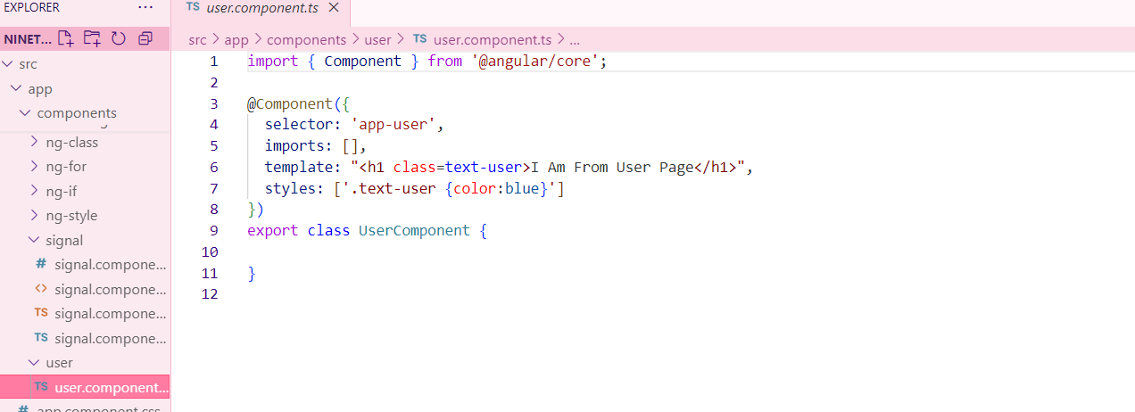

* **What is standalone component?**

component that does not require a module (NgModule) to be declared. It is a self-contained unit that can be used directly in the application without being registered inside app.module.ts.

ng g c my-component --standalone

* **How to Declare Variable / state in Component?**

In Angular, you can declare variables (state) inside the component class using TypeScript properties.

* **What is selector?**

A selector is used to identify each component uniquely into the component tree.

* **What is a template?**

Template is an HTML view of Angular in which we can write directives.

Two types (inline and separate physical HTML file.)

* **What is a module & what is app.module.ts?**

Module is a place where you can group the components, directives, pipes and services which are related to the application.

* **How an Angular App gets Loaded and Started? What are index.html, app-root, selector and main.ts?**

Angular is used to create Single Page Applications. index.html file is that single page. Index.html will invoke main.js file which is the JavaScript version of main.ts file.

main.ts file is like the entry point of the web app. It compiles the web app and bootstraps the AppModule to run in the browser.

App module file will then bootstrap the AppComponent.

AppComponent or app-root component is the HTML which you will see finally.

* **What is a Bootstrapped Module & Bootstrapped Component?**

When the Angular web application starts, the first module launched is the bootstrapped module, and the same is true for the bootstrapped component also.

Bootstrap component is an entry component that Angular loads into the DOM during the bootstrap process or application launch time.

* **What is Data Binding in Angular?**

Databinding is the communication between typescript view and the component of HTML view.

Or

Data Binding in Angular is the mechanism that connects the component's data (TypeScript logic) with the view (HTML template). It ensures that changes in the component reflect in the UI and vice versa.

* **What is String Interpolation in Angular?**

One-way data-binding technique that is used to transfer the data from a **TypeScript code (component)** to an **HTML template (view).**Denote by {{}} or Double curly

**Interpolation** - one-way data-binding technique that is used to transfer the data from a **TypeScript code (component)** to an **HTML template (view).**

**It will work only with string type.**

**It is represented only inside bouble braces.** {{data}}

* **What is Property Binding in Angular?**

**INPUT DATA**

**Property Binding** - One-way binding from to transfer the data from a **TypeScript code (component)** to an **HTML template (view).**

**It** **is a** **superset of interpolation**.

**it can set an element property to a non-string data.** [property] =”data”

* **What is Event Binding in Angular?**

**OUTPUT DATA**

**Event Binding** - (event) =”expression”→ One-way binding from UI to the component or (HTML to TS)

Many events are available, for example: mouseover, dblclick, change, and click.

* **What is Two way Binding in Angular?**

**TWO WAY DATABINDING**

**Two-Way Binding** - Two-way data binding in Angular will help users to exchange data from the view to component and then from component to the view at the same time

[(ngModel)] =”data”→

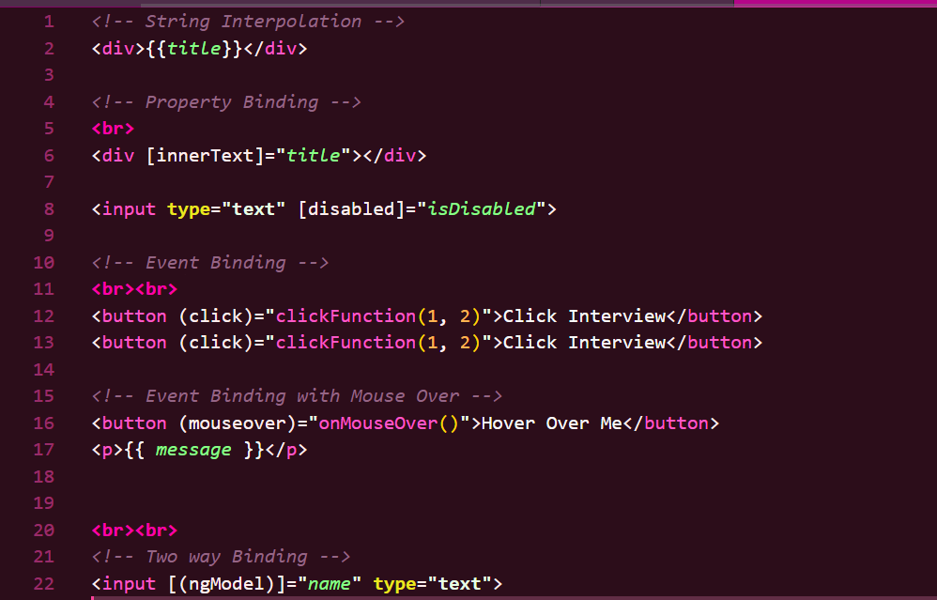

* **What are directives in Angular? and different types of Angular directives?**

Directives are special type of classes that add additional behaviour to elements.

Angular syntax which can write inside HTML, so that we can change the behaviour of HTML DOM and it add dynamic behavior to elements in Angular Application.

Hint: Whenever you need to use ngModel, the name attribute is mandatory.

Inside a class, we must declare a variable with a data type so that it can be used for display.

If we need to show data on page load, we must define it in the constructor.

Helps in capturing user input value:

[(ngModel)] = "declaredVariable"

{{ declaredVariable }} → The user input value will be displayed.

[ngClass]="isChecked ==true? ‘’:’’ ">

If you want to assign the value entered in a text box to another field using ngModel, you can do this by updating the second field dynamically in the component.

Angular has three types of directives:

1. Component Directives (Most Common) → Customized user control. Directives with template (@Component)
2. Structural Directives → Change the DOM layout by adding or removing elements. (*ngIf, *ngFor, *ngSwitch)
3. Attribute Directives → Modify the appearance or behaviour of an HTML element ([ngClass], [ngStyle], Custom directives)

* **What is *ngIf Structural directive?**

To display elements conditionally

example:

On click of hide button it should hide and vice versa.

In order to use the NgIf directive, structural directives, or attribute directives, we need to import CommonModule or NgIf in component.ts under imports: [NgIf].

To hide or show an element, we must use *ngIf on that element in older Angular versions.

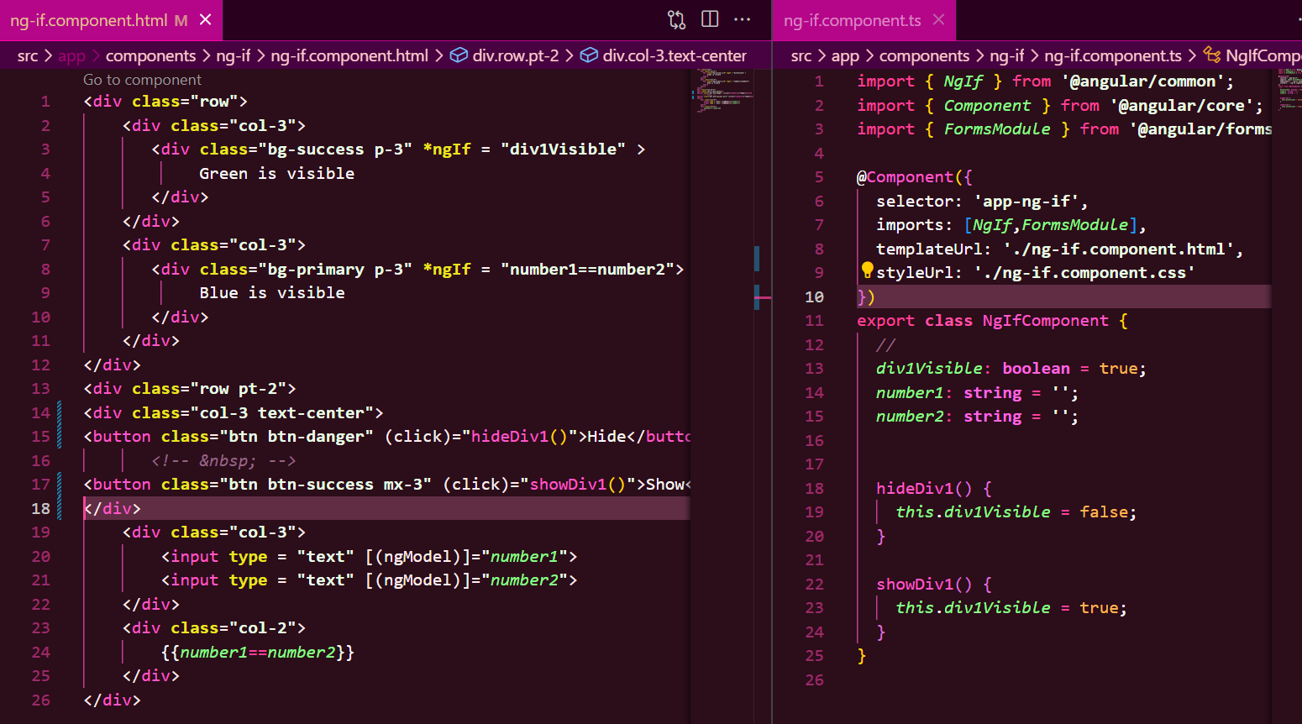

Another example

* **What is *ngFor Structural directive?**

To iterate a list of items.

Use *ngFor to loop through arrays and generate elements.

NgFor (for loop, iterator) dynamically creates elements.

**Dynamic: dynamic behaviour refers to the ability to change content, styles, properties, or data dynamically based on user interactions, API responses, or conditions.**

The *ngFor directive is used to loop through arrays and dynamically create elements.

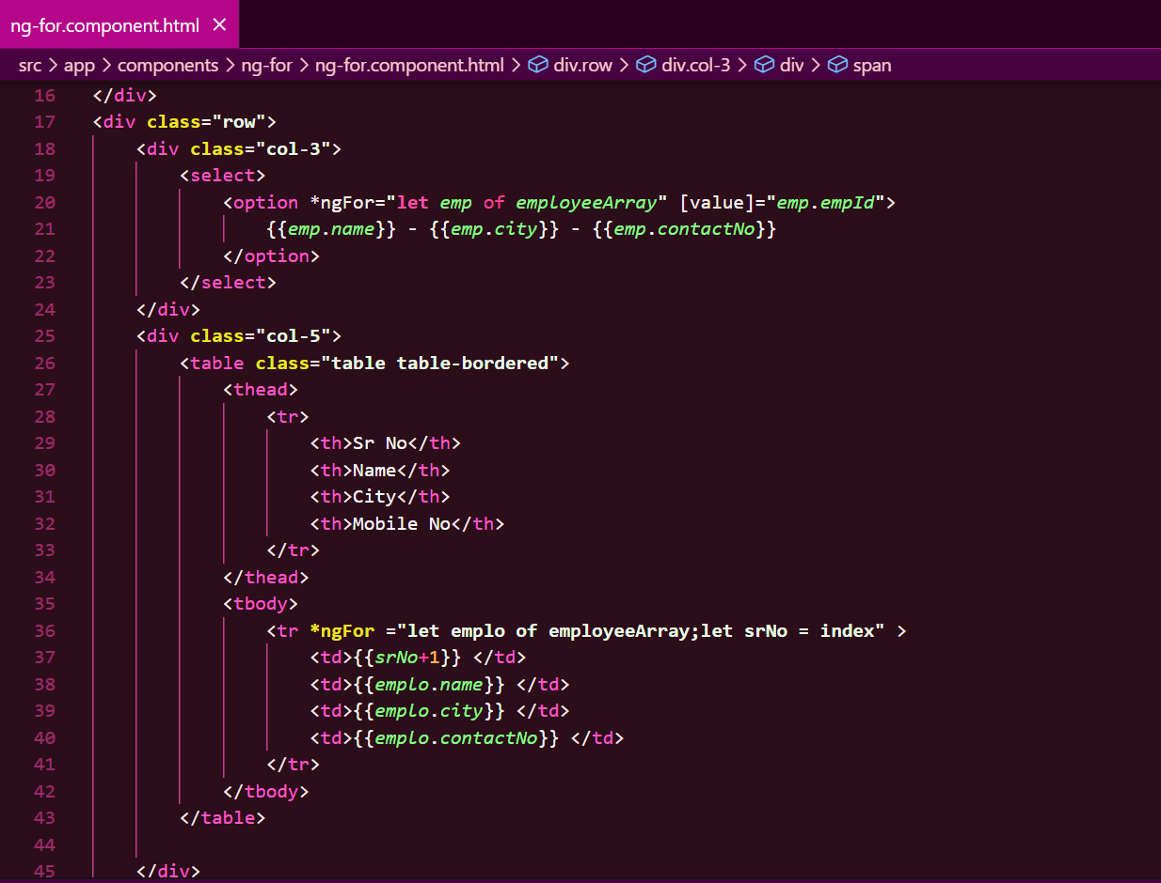

* **What is *ngSwitch Structural directive?**

Used in combination with *ngSwitchCase and *ngSwitchDefault

* **What is [ngStyle] Attribute directive?**

It updates the style for the HTML element.   
Adding the style directly.

Use [hidden] or [ngStyle] to toggle visibility.

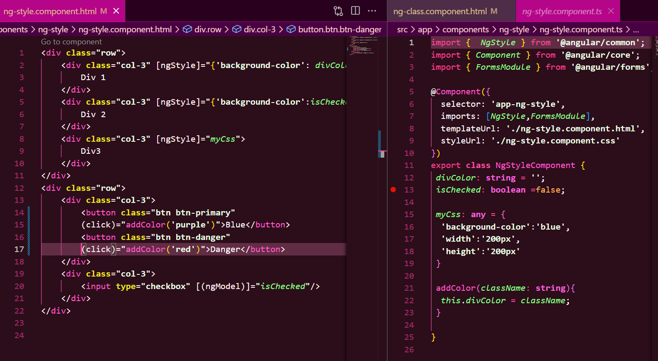

* **What is [ngClass] Attribute directive**It updates the style for the HTML element.

Adding style by using CSS class.

Use Renderer2 for advanced dynamic element creation.

Attribute Directives (modify the appearance): [ngClass], [ngStyle].

Using the [ngClass] directive, we can dynamically assign CSS classes to an element.

* **What is the difference between Component, Attribute and Structural Directives?**

* **What is Decorator?**

decorators are special functions used to add metadata to classes, properties, methods, and parameters

**What are the types of Decorator?**

**@Component** : .ts file

**@Injectable: service file**

**@NgModule**

**@Input** : parent to child

**@Output:** child to parent

* **What is a decorator in Angular? Or What are Annotation or Metadata?**

Defines what kind of angular class it is..

@component denotes Angular component.

@NgModule denotes Angular Module

* **What are Pipes? What are the types of Pipes & Parameterized Pipes?**

Pipes in Angular are used to transform data in templates before displaying it to the user.

Types of pipes:

1. **Built-in Pipes**: e.g., DatePipe, CurrencyPipe, UpperCasePipe.
2. **Async Pipe**: Used to handle asynchronous data like Observables or Promises.
3. **Custom Pipes**: User-defined pipes for specific transformations.

* **What is Chaining Pipes?**

Practice of applying multiple pipes consecutively in a template to transform data

**Explain architecture of Angular?**

**⬇️ User Clicks a Button**

**┌──────────────────────────────────────────┐**

**│ COMPONENTS (UI + Logic) │**

**│ - app.component.ts (Controller) │**

**│ - app.component.html (View) │**

**└──────────────────────────────────────────┘**

**⬇️ Calls Service**

**┌──────────────────────────────────────────┐**

**│ SERVICES (Business Logic) │**

**│ - Fetch data from APIs │**

**│ - Perform calculations │**

**└──────────────────────────────────────────┘**

**⬇️ Uses DI to Fetch Data**

**┌──────────────────────────────────────────┐**

**│ DEPENDENCY INJECTION (DI) │**

**│ - Inject services into components │**

**└──────────────────────────────────────────┘**

**⬇️ Updates the UI**

**┌──────────────────────────────────────────┐**

**│ DIRECTIVES & PIPES │**

**│ - *ngIf, *ngFor (Structure) │**

**│ - ngClass, ngStyle (Styling) │**

**│ - Pipes (Data Transformation) │**

**└──────────────────────────────────────────┘**

* **What is SPA in Angular?**

SPA is single page Application where the main UI gets loaded ay once and the needed UI gets loaded on need.

* **How to implement SPA in Angular?**

We have to use Angular routing, Routing is a simple collection in Angular.

* **How to implement routing in Angular?**
* **Explain Lazy Loading ?**

Angular loads modules only when needed, reducing the initial load time. It’s done by using loadChildren in the route configuration.

* **How to implement Lazy Loading in Angular?**
* **Explain Services with Example?**

A service is a typescript class and a **reusable code** which can be used in multiple components.

Service can be implemented with the help of dependency injection.

We can create a **centralized or common data** service.

**Data communication** between the components.

* **How to create Servicein Angular?**

Using the command ng generate service service-name.

* **Differentiate between ng Serve and ng build?**

ng serve runs the app locally for development with live reloading.  
ng build creates optimized files for production deployment.

* **Explain the --prod parameter in ng build ?**
* **What is @Input decorator? How to transfer data from parent to child component.**

@input decorator is used to transfer data from parent to child component.

@input(): ability to receive data from outside component

1. **Two-Way Binding (Parent Component)**
   * Between app.component.ts and app.component.html
   * Uses [(ngModel)] for form elements---(import commonModule).
2. **Data Transfer from Parent to Child (@Input)**
   * Parent (app.component.ts) sends data to child using @Input()
   * Example: <app-child [data]="parentData"></app-child>
3. **Data Rendering in Child (Interpolation)**
   * Child (child.component.html) receives and displays data using {{ data }}

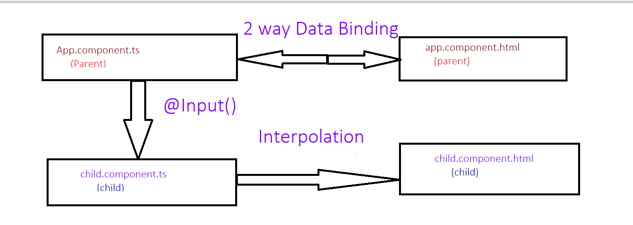

* **What is @Output decorator? How to transfer data from child to parent component.**

@Output decorator and event emitter together are used to pass data from child to parent component.

* **What is Depedency Injection?**

To use a service in a component, inject it via the constructor. Directives are applied in templates using selectors."

💡 Note:

* Services are injected in the constructor.
* Directives are added in the template (e.g., *ngIf, [ngClass]). They are not injected like services.

making the code **cleaner, reusable, and easier to test**.

* **How to implement Depedency Injection? Or How to use Dependency Injector with Services in Angular?**

Use the service in component

**constructor(private dataService: DataService) {**

**this.data = dataService.getData();**

**}**

* **What’s the benefit of Depedency Injection?**

Loose coupling, better maintainability, and improved testability.

* **What is Hierarchical Dependency Injection? (In old Angular ).**

In angular if we inject any service in parent with help of provide it is available to all the child’s under it.

If we inject to any of the child component, that will be accessible to the belonging child but not to the siblings or parent.

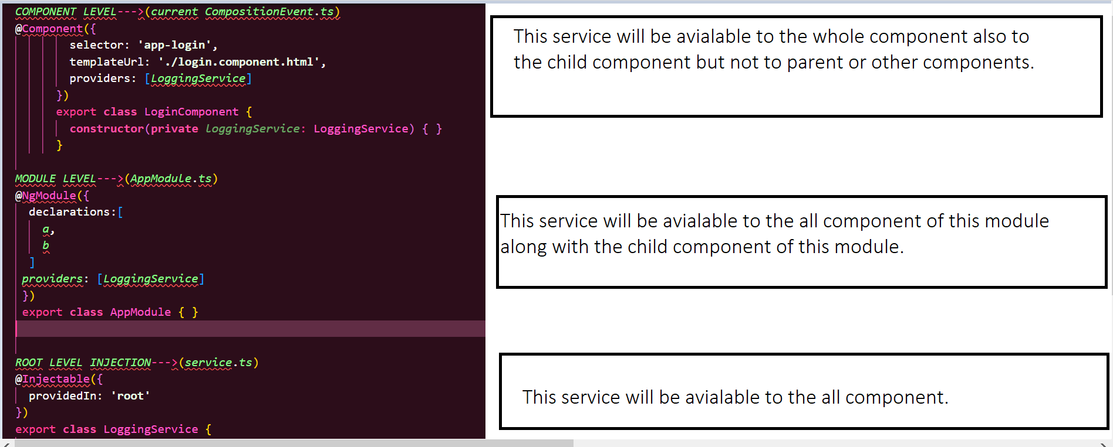

* **What is Provider in Angular? (In old Angular ).**

provider is an object that defines how to create or obtain a service. It tells Angular how to inject a service into a component or other services. Providers are used to configure the Angular Dependency Injection system.

* **What is the role of @Injectable Decorator in a Service?**

The @Injectable decorator marks a class as a service that can be injected into other components or services using dependency injection.

* **What are Parent-Child Components?**
* **What are Lifecycle Hooks in Angular?**

A component from creation to destruction goes through several stages and these stages are the life cycle hooks.

The stages will cover activities like:

Component Instantiating.

Rendering the component HTML view.

Creating the child components if required.

Destroying the components.

|  |
| --- |
|  |

* **What is ngOnInit life cycle hook in Angular?**
* **What is the difference between constructor and ngOnInit?**

|  |  |
| --- | --- |
| **ngOnInit** | **Constructor** |
| 1. NgOnInit is an Angular lifecycle hook, which signals the activation of the created component. | The constructor is a method in a TypeScript class, that automatically gets called when the class is being instantiated. |
| 2. ngOnInit is called after ngOnChanges lifecycle-hook. | Constructor is called before any lifecycle-hook. |
| 3. When ngOnInit is called, everything about the component is already ready, so it’s used to perform most of the business logic on the component. | When the constructor is called, everything in the component is not ready, so it's mostly used for injecting dependencies only. |

* **What are Asynchronous operations?**

Example: Fetching data from an API or reading a file without freezing the application.

* **What is the difference between Promise and Observable?**

Both are used to transfer the data in javascript asynchronously.

| **Observables** | **Promises** |
| --- | --- |

|  |  |
| --- | --- |
| **1.** Emit **multiple** values over a period of time. Also called **streaming of data**. | Emit a **single** value at a time. |

|  |  |
| --- | --- |
| **2.** Are **lazy**: they’re not executed until we **subscribe** to them using the subscribe() method. | Are **not lazy**: execute **immediately** after creation. |

|  |  |
| --- | --- |
| **3.** Have subscriptions that are **cancellable** using the unsubscribe() method. | Are **not cancellable**. |

* **What are Angular forms and its types?**

Angular forms used to handle users input.

Types of forms:

1.Template Form: most of the code will be written in .html file

2.Reactive Forms: most of the code will be written in component.ts file.

| **Template Driven Forms** | **Reactive Forms** |
| --- | --- |

|  |  |
| --- | --- |
| **1.** Most code and validation logic is written in **HTML template**. | Most code and validation logic is written in **component TypeScript class file**. |

|  |  |
| --- | --- |
| **2.** Requires adding **FormsModule** in AppModule to activate it. | Requires adding **ReactiveFormsModule** in AppModule to activate it. |

|  |  |
| --- | --- |
| **3.** Used when the application is **simple** and has **fewer controls**. | Used when the application is **complex** and has **more controls**. |

* **What is RxJS?**

RxJS (Reactive Extensions for JavaScript) is a library for handling asynchronous events and data streams using Observables

* **What is Observable? How to implement Observable**

An Observable in RxJS is a core concept used for handling asynchronous data streams. It represents a collection of future values or events that can be observed over time.

* **What is the role of HttpClient in Angular?**

The HttpClient in Angular is a service that allows you to make HTTP requests (like GET, POST, PUT, DELETE) to interact with backend servers and APIs.

* **What is routing and how to set it in Angular?**

Routing helps in navigating from one view to another view with the help of URL.

How to setup Routing in Angular?

1. Create Angular project with Routing option
2. Create components for routing
3. Configure Routes
4. Configure links

In Angular 19:

In app.routes.ts need to add the pat and its component name

{

        path:**'admin'**,

        component:*AdminComponent*

},

In app.components.html needs to add the navigation link.

<li **class**=**"nav-item"** >

**<a class="nav-link active" routerLink="admin">**Admin**</a>**

 </li>

Router link is used to navigate to different route.

* **What is the role of HTTP client in Angular?**

**HttpClient** is a **built-in service** class available in Angular.  
 @angular/common/http package.  
Performs **HTTP requests**.s

* **What is the HTTP Interceptor? When and where to use Angular?**

HTTP Interceptor are special services only which are used to intercept HTTP requests’

* **What is typescript and why do we need it?**

It adds types to JavaScript or superset of JavaScript.

* **What is Typescript? Or What is the difference between Typescript and Javascript?**

TypeScript is a superset of JavaScript that adds static typing and modern features like classes, interfaces, and type annotations. The main difference is that TypeScript allows for type checking at compile time, while JavaScript is dynamically typed and runs directly in the browser.

* **What is the difference between let and var keyword?**
* **What is Type annotation?**
* **What are Built in/ Primitive and User-Defined/ Non-primitive Types in Typescript?**

**Primitive types** are data types.

**Non-primitive types** are more complex, like objects and arrays.

* **What is “any” type in Typescript?**

**Any type:** Accepts any type of data

* **What is Enum type in Typescript?**

An Enum in TypeScript is a way to define a set of named constants, making it easier to work with sets of related values. It allows you to represent a collection of values with meaningful names, improving code readability and maintainability.

* **What is Type Assertion in Typescript?**
* **What are Arrow Functions in Typescript?**

Arrow functions are a shorter syntax for writing functions.

**Angular 19 preparation document.**

**HINT: in order to use “ng serve or ng s” in terminal use the command "Set-ExecutionPolicy -ExecutionPolicy RemoteSigned -Scope CurrentUser"**

**What is Component?**

In Angular, a **Component** is a fundamental building block of the application. It controls a portion of the UI (User Interface) and is responsible for managing the data and logic associated with that part of the view. Components are reusable and modular, making it easier to build and maintain complex applications.

OR

Is a mediator between view and the module.

**Key Features of an Angular Component:**

1. **Template**:
   * The template defines the HTML structure of the component. It determines how the component is rendered in the DOM.
   * Templates can include Angular-specific syntax like data binding, directives, and pipes.
2. **Class**:
   * The class is written in TypeScript and contains the logic and data for the component.
   * It uses the @Component decorator to define metadata about the component (e.g., selector, template, styles).
3. **Metadata**:
   * The @Component decorator provides metadata that tells Angular how to process the component.
   * Metadata includes properties like selector, templateUrl, styleUrls, etc.
4. **Styles**:
   * Styles define the appearance of the component. They can be inline, external, or scoped to the component.
5. **Selector**:
   * The selector is a custom HTML tag (e.g., <app-my-component>) used to embed the component in other templates.

Example of an Angular Component:

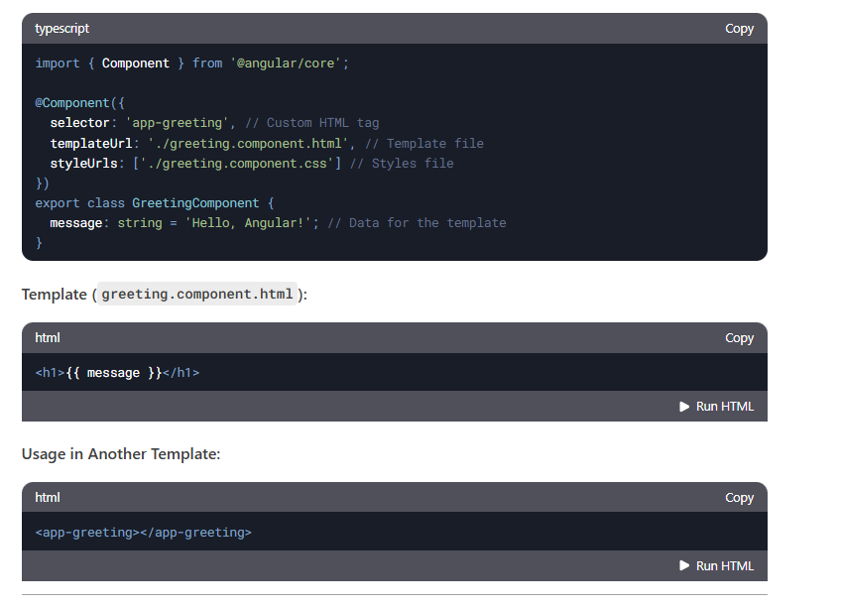

**Why Use Components?**

* **Reusability**: Components can be reused across the application.
* **Modularity**: Each component encapsulates its logic, template, and styles.
* **Maintainability**: Breaking the UI into smaller components makes the code easier to manage and test.

**How to create component?**

In order to create component use command   
ng generate component <component name> **(or)** ng g c <component name>

Each component contains below files.

app.component.html--->HTML code with app component should define

app.component.css---> CSS code

app.component.ts--> should import rendering app component

app.component.specs.ts

**What is Component Decorator ?**

The @Component **decorator** is a function that marks a **TypeScript class** as an Angular **component** and provides configuration metadata that determines how the component should be processed, instantiated, and used at runtime.

**How to Render component ?**

Step 1: Create a Component

Step 2: Use the Component in Another Component (app.html)

Step 3: Ensure the Component is Declared in app.module.ts.

To display UI values from the .html file, they must be defined in the corresponding component (.ts file).

Example:

imports: [DataBindingComponent], in app.component.ts

<app-data-binding></app-data-binding> in app.component.html

**OR**

**create single File component ?**

instead of having html and css, specs.ts and ts we can have only ts file with help of directive.

use template and styles instead of templateURL and styleUrls in Component decorator.



**What is standalone component?**

component that does not require a module (NgModule) to be declared. It is a self-contained unit that can be used directly in the application without being registered inside app.module.ts.

ng g c my-component --standalone

**How to Declare Variable / state in Component?**

In Angular, you can declare variables (state) inside the component class using TypeScript properties.

**What is Data Binding?**

Data Binding in Angular is the mechanism that connects the component's data (TypeScript logic) with the view (HTML template). It ensures that changes in the component reflect in the UI and vice versa.

There are four main types of data binding in Angular:

1. **Interpolation** - {{}} → One-way binding from component to view
2. **Property Binding** - [property] → One-way binding from component to an HTML element
3. **Event Binding** - (event) → One-way binding from UI to the component
4. **Two-Way Binding** - [(ngModel)] → Two-way sync between component and UI

**What is Directive?**

A Directive in Angular is a special type of class that allows you to modify the behavior, appearance, or structure of DOM elements.

Directives are used to extend HTML capabilities and add dynamic behavior to elements in Angular applications.

Hint: Whenever you need to use ngModel, the name attribute is mandatory.

Inside a class, we must declare a variable with a data type so that it can be used for display.

If we need to show data on page load, we must define it in the constructor.

Many events are available, for example: mouseover, dblclick, change, and click.

**What Are Types of Directive ?**

Angular has three types of directives:

1. Component Directives (Most Common) → Directives with a template (@Component)
2. Structural Directives → Modify the DOM structure (*ngIf, *ngFor, *ngSwitch)
3. Attribute Directives → Modify the appearance or behavior of an element ([ngClass], [ngStyle], Custom directives)

To use ngModel, you must import FormsModule in the module file (e.g., app.module.ts) and include it in the imports array: imports: [FormsModule]. Similarly, for *ngIf, you need to import NgIf, and for *ngFor, you need to import NgFor.

**How to use ngModel directive?**

Helps in capturing user input value:

[(ngModel)] = "declaredVariable"

{{ declaredVariable }} → The user input value will be displayed.

[ngClass]="isChecked ==true? ‘’:’’ ">

If you want to assign the value entered in a text box to another field using ngModel, you can do this by updating the second field dynamically in the component.

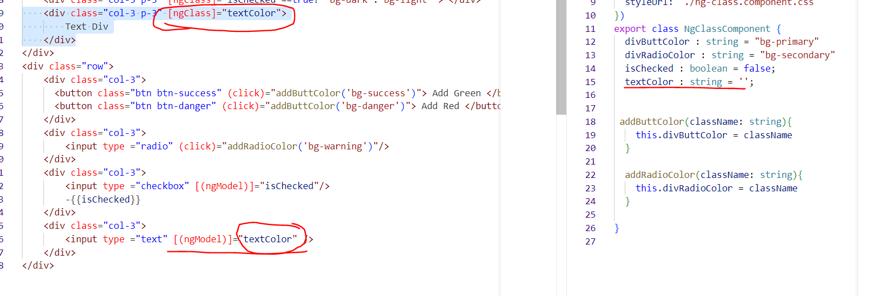

**What Are Structural Directive ?**

**How to use *ngIf Directive ? or How to Hide and Show Element in Angular ?**

The *ngIf directive is used to conditionally display elements based on a boolean condition

**How to use *ngFor Directive ? or How to Create Dynamic Element in Angular ?**

**Dynamic: dynamic behavior refers to the ability to change content, styles, properties, or data dynamically based on user interactions, API responses, or conditions.**

The *ngFor directive is used to loop through arrays and dynamically create elements.

**Use *ngIf to conditionally display elements.  
Use *ngFor to loop through arrays and generate elements.  
Use [hidden] or [ngStyle] to toggle visibility.  
Use Renderer2 for advanced dynamic element creation.**

**In order to use the NgIf directive, structural directives, or attribute directives, we need to import CommonModule or NgIf in component.ts under imports: [NgIf].**

**To hide or show an element, we must use *ngIf on that element in older Angular versions.**

**NgFor (for loop, iterator) dynamically creates elements.**

**Structural Directives (modify the DOM): *ngIf, *ngFor, *ngSwitch.**

**Attribute Directives (modify the appearance): [ngClass], [ngStyle].**

**Using the [ngClass] directive, we can dynamically assign CSS classes to an element.**

**What Are Attribute Directive ?**

**How to use [ngClass] Directive ? and How to Add Dynamic Class ?**

In order to use ngclass either import**: commonModule** or **NgClass** in .ts file.

The declared variable needs to assign for ngClass.

**[ngClass]=”divColor”**

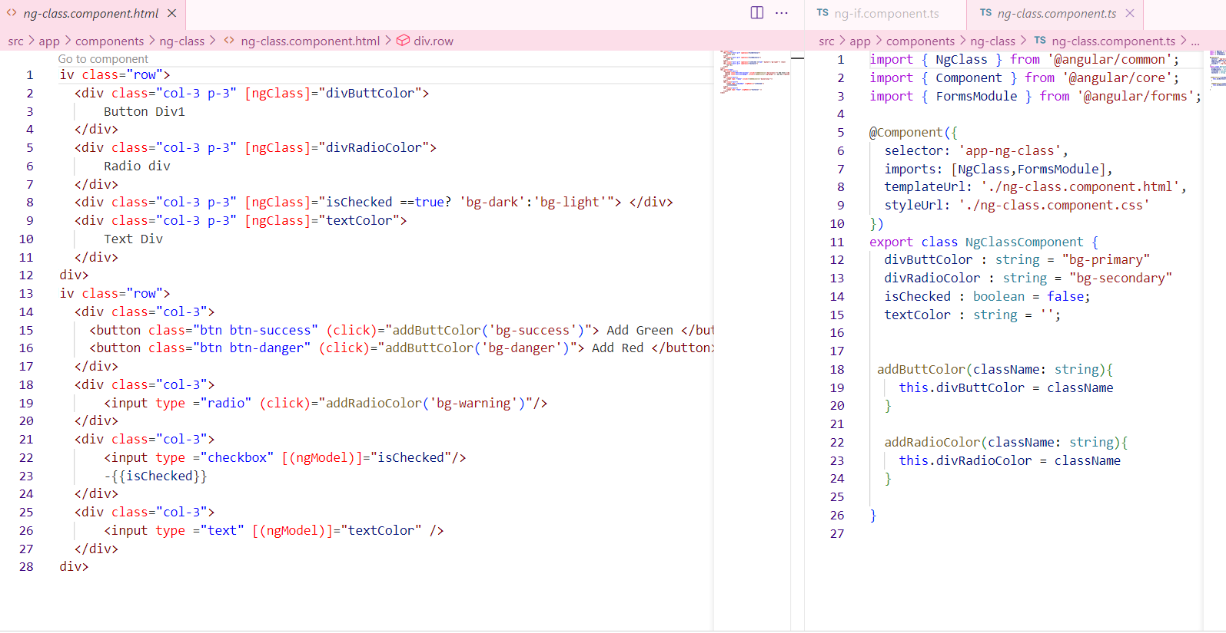

**How to use [ngStyle] Directive ? and How to Add Dynamic CSS / Style?**

Using of ngStyle added background color to the variable.

**2nd example:**

**What is Control Flow Statement ?**

**ngIf and ngFor needs to import: commonModule** or **NgIf/NgFor**

**How To use @if, @else if , @else ?**

**How to use @for ?**

**What is Signal ?**

When a change is detected, **Zone.js** will detect it and update the UI. Even if **Zone.js** is turned off, signals will still detect changes.

To simplify state management and change detection. They help track and react to changes in data more efficiently.

**How to Create Signal And Update Signal ?**

Creation of signal is like same as variable except there is keyword signal.

We can create signal with and without data type.

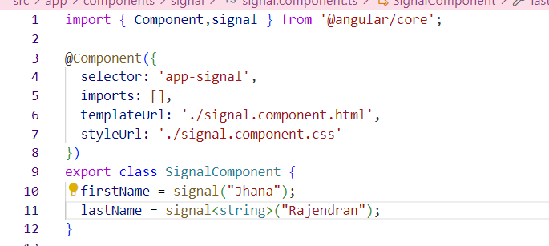

**How to Access Signal Value ?**

**We can access value as a method.**

**How to use set , update method ?**

**What is Linked Signal ?**

If there is a dependent signal, and one of the signals changes, the linked signal (or computed signal) will automatically update. This is because computed signals track dependencies and recalculate when any of their dependencies change.

**How to Create Linked Signal?**

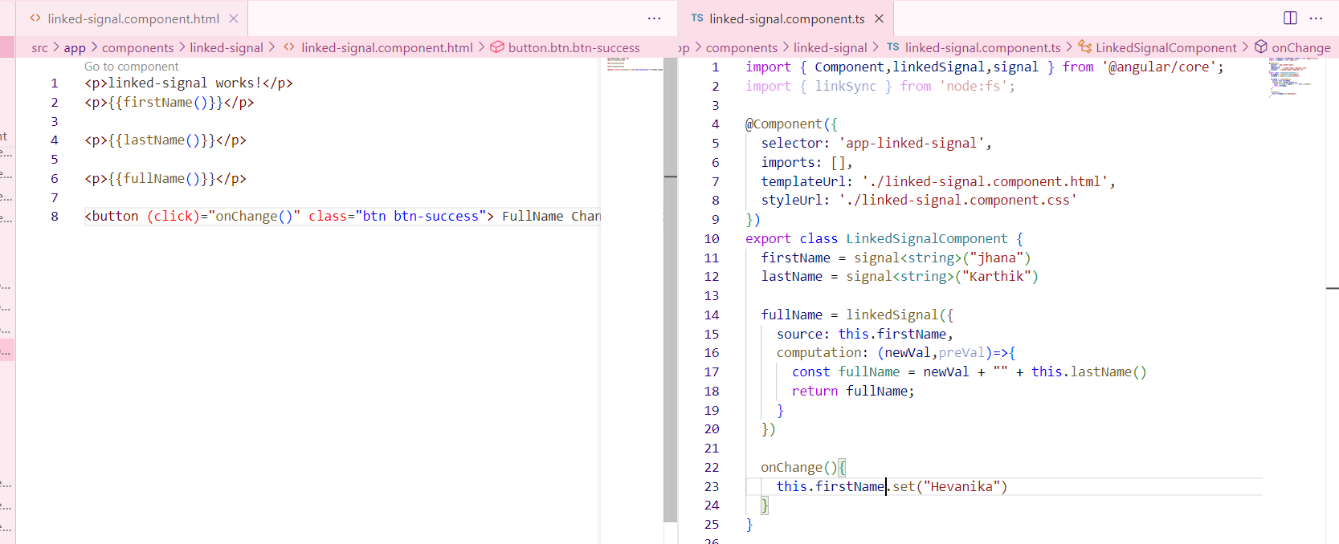

**What is computation and equal in Linked Signal ?**

**What is Routing ?**

Notes: Creating a URL for your components.

Starting from Angular 19, a constant file app.routes.ts is generated by default. In Angular, a route is an object that defines a path and its associated component.

Routing in Angular enables navigation between different views (components/pages) within a Single Page Application (SPA). It allows users to switch between pages without a full-page reload, providing a smoother experience.

**How to Create Routes ? AND How to Create Default Route ?**

Default route will be declared as.

Declare the necessary routes in app.routes.ts and pass this route to app.config.ts.

**What is router-outlet ? AND What is RouterLink ?**

When using navigation links in app.component.html, you must include <router-outlet> to display routed components.

The rule is that whatever you need to use must be imported in app.component.ts. For example, <router-outlet> must be imported in app.component.ts

**How to do Navigation in Angular ?**

By using router link we can achieve navigation.

In order to perform navigation from .html file use routerLink=

In order to perform logical navigation from .ts file must use router services.

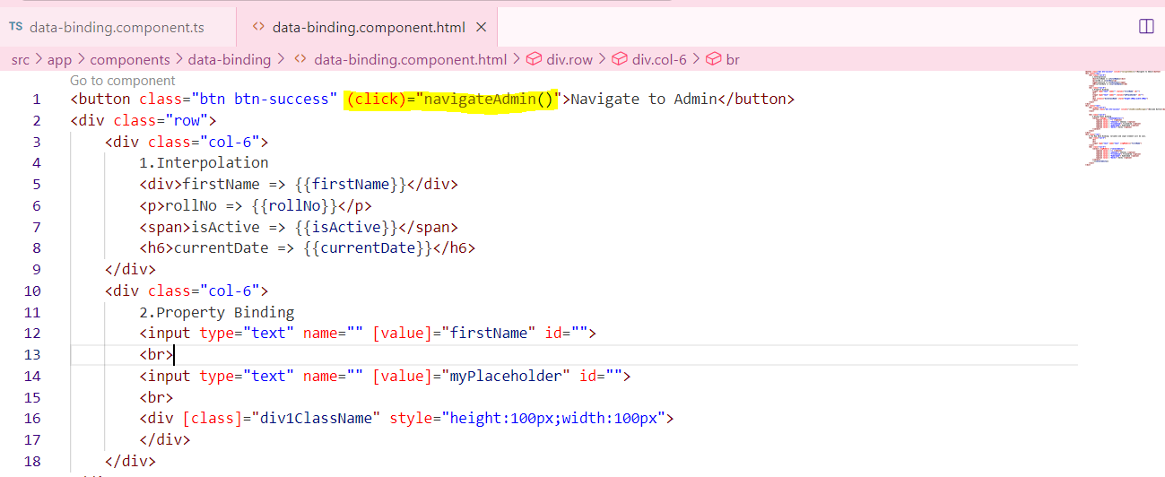

**Form Types in Angular ?**

Bind an object to a form using ngModel is called Template Form.

**How to Create Template Form ?**

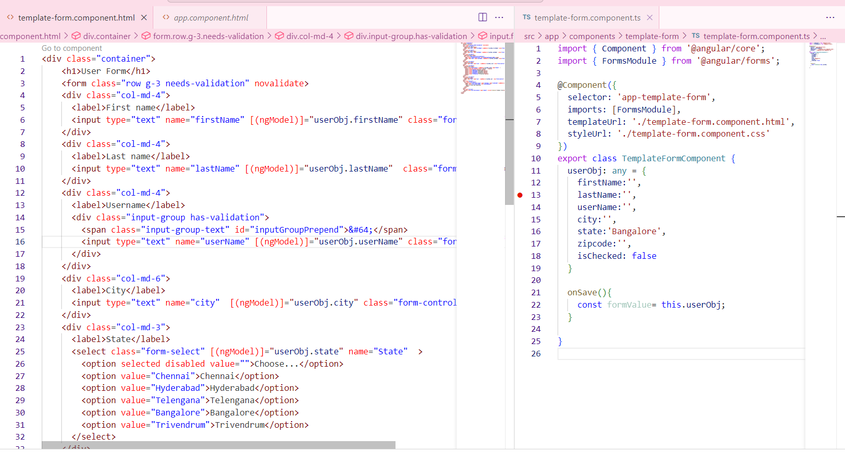

**How to Validate Template Form Use of ngModel in template Form ?**

In template form we need to add validation in HTML.

Creating # property we can validate.

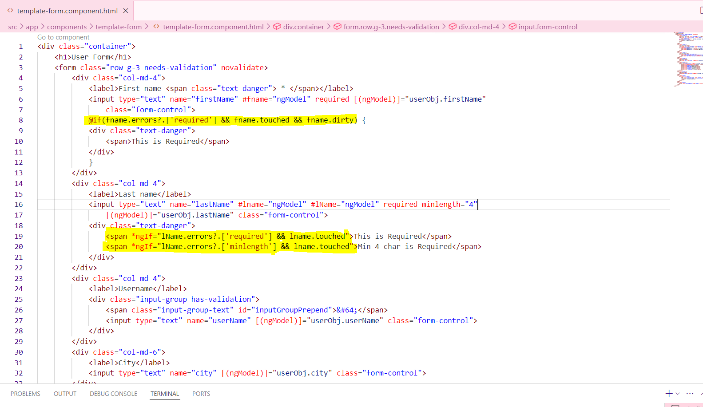

**How to Create Reactive Form in Angular ?**

Import FormGroup and FormControl from @angular/forms.

Initialize the bind form with fields inside the constructor.

All input name should bind in formcontrolName

Reactive form FormGroup is best approach.

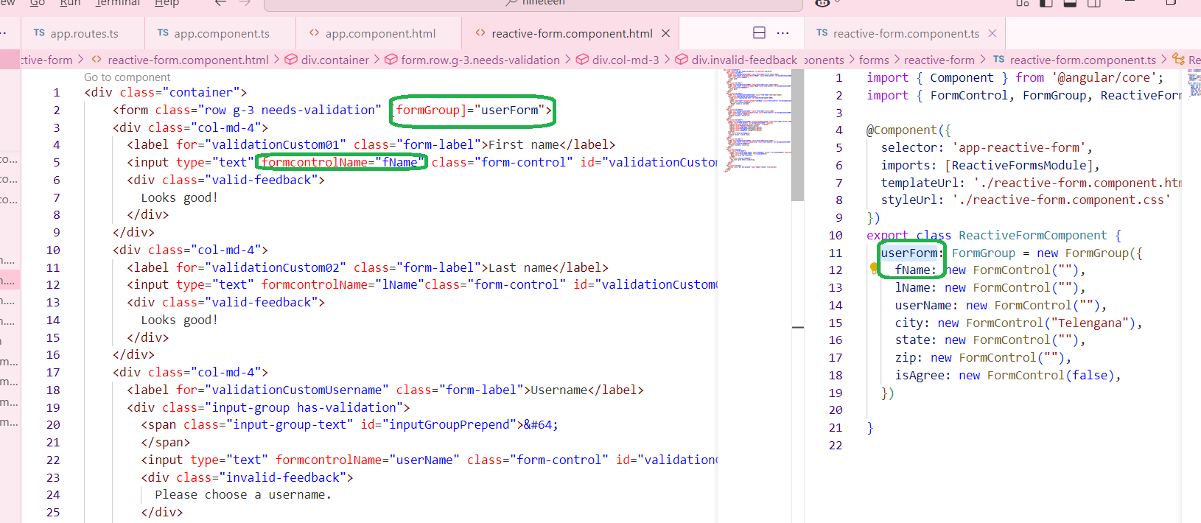

We can get complete form value on submit, so that we can send this object in API.

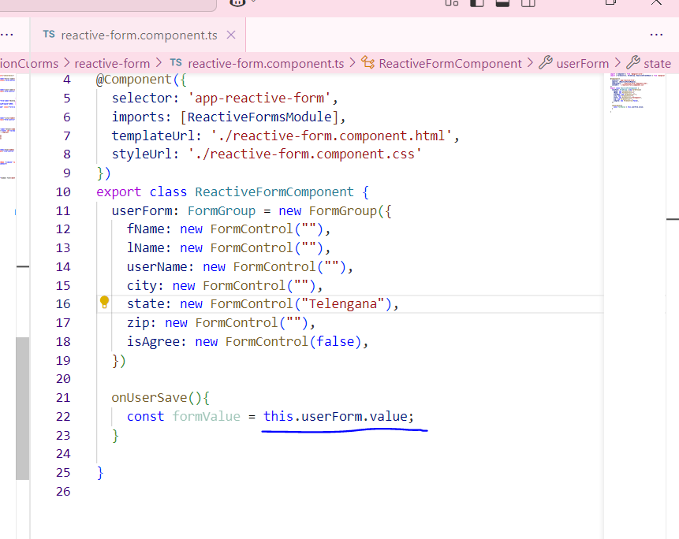

**How to Validate Reactive Form in Angular ?**

In reactive form we need to add validation while creating form.

Validation must pass as an array because there is multiple of validations avail.

Can validate using form. Control example: 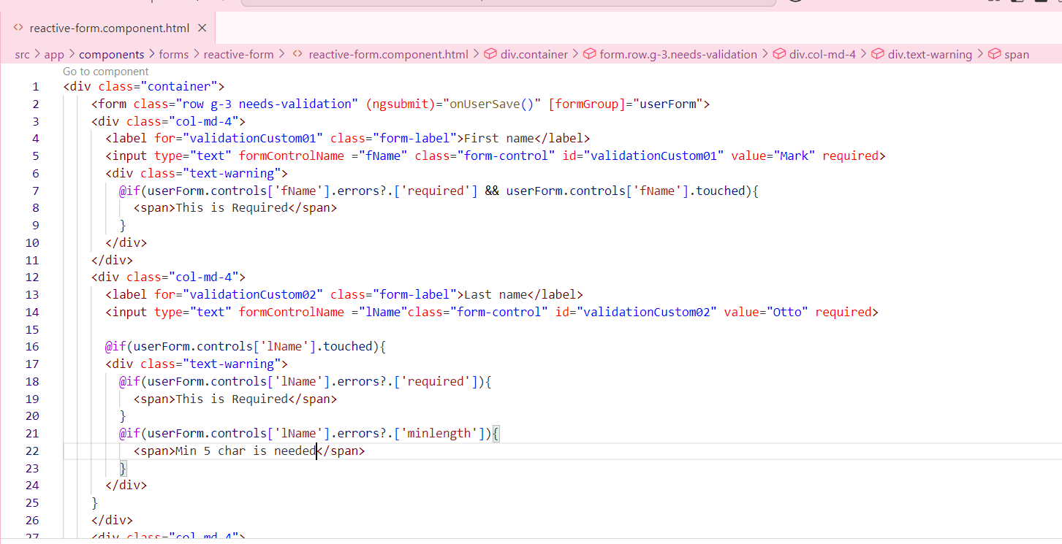

**What is Form Control ?**

**How to Disable Form Control ?**

If need to disable the control for the field.

1.create a constructor.

2.disable that particular field.

We have an enable option also.

Const isValid =this.userForm.valid;-🡪 Whole form valida..

**What is API ?**

Application programming interface, a set of protocols and definitions that allow different software components or programs to communicate with each other and share data.

In order to use API first need to add provideHTTPclient() in providers array avail in app.config.ts file.

**

**What is HttpClient ?**

**What is GET API ?**

**GET RECORDS**

**How to Integrate GET API call ?**

**How to Store api Response ?**

**What are Fake API ?**

**What is POST API ?**

**TO CREATE RECORDS**

**How to Integrate POST API ?**

**POST API With Template form ?**

**What is PUT API ?**

**TO UPDATE EXISTING RECORDS**

**How to Integrate PUT API ?**

**PUT API With Template form ?**

**What is DELETE API ?**

**TO DELETE EXISTING RECORDS:**

**How to Integrate DELETE API ?**

**Show confirmation before Deleting Record**

**What is Resource API ?**

It provides a declarative way to manage API calls, making it easier to fetch, store, and reuse data across components without manually managing state.

**For which Purpose We have to use Resource API in angular 19?**

**How to make api call with Resource API in angular 19? and What are loader and reload function in Resource API in angular 19?**

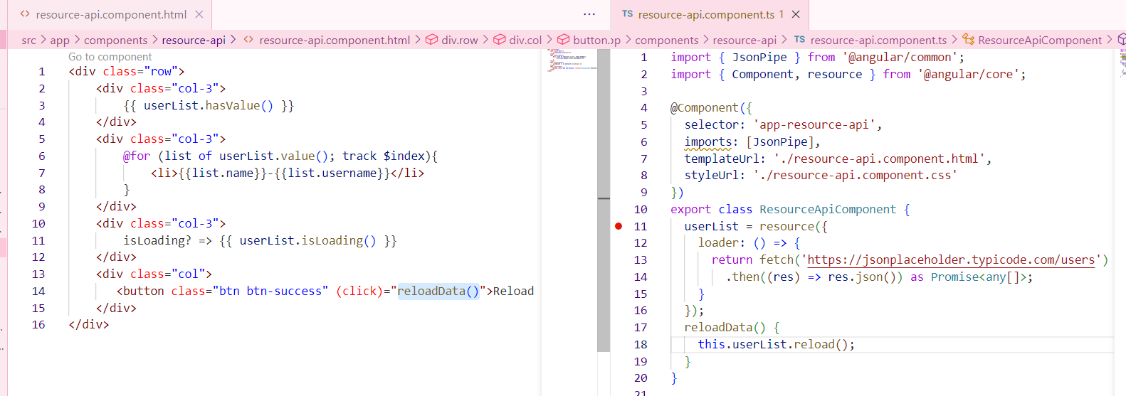

**What is Service ?**

**For which Purpose We have to use Service ?**

**How to create api call Function in Service ?**

**Angular CRUD with api with Service call Functions ?**

**What are Life Cycle Events ?, Types of Life cycle Events ? Which one We mostly Use and Their UseCase ?**

Life Cycle Events are function which called automatically when they are needed.

**Lifecycle of a Component:**

Angular components have a lifecycle managed by Angular. Key lifecycle hooks include:

ngOnInit(): Called after the component is initialized. (We can use to trigger Api call function)

constructor(): is to initialize the variable.

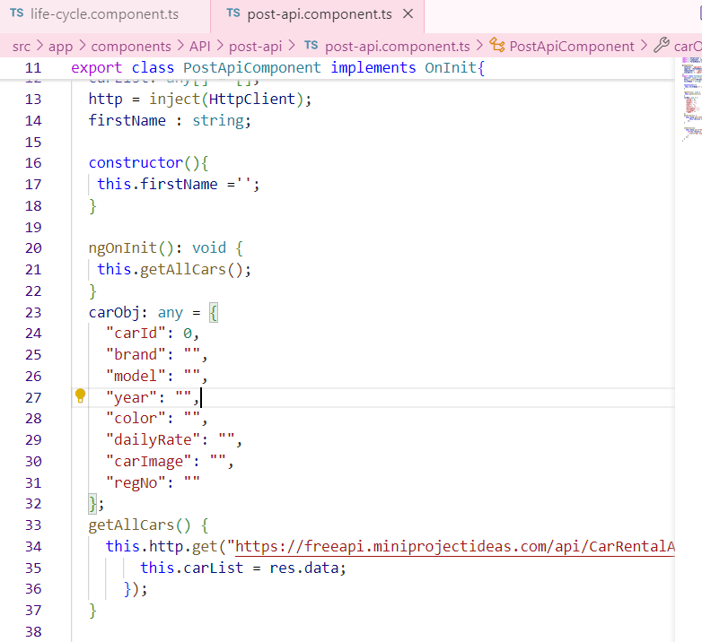

ngOnChanges(): Called when input properties change.

ngAfterViewInit():view child, getting reference of element..(how much our UI taking time to load)

ngOnDestroy(): Called before the component is destroyed.. (while leaving the page).

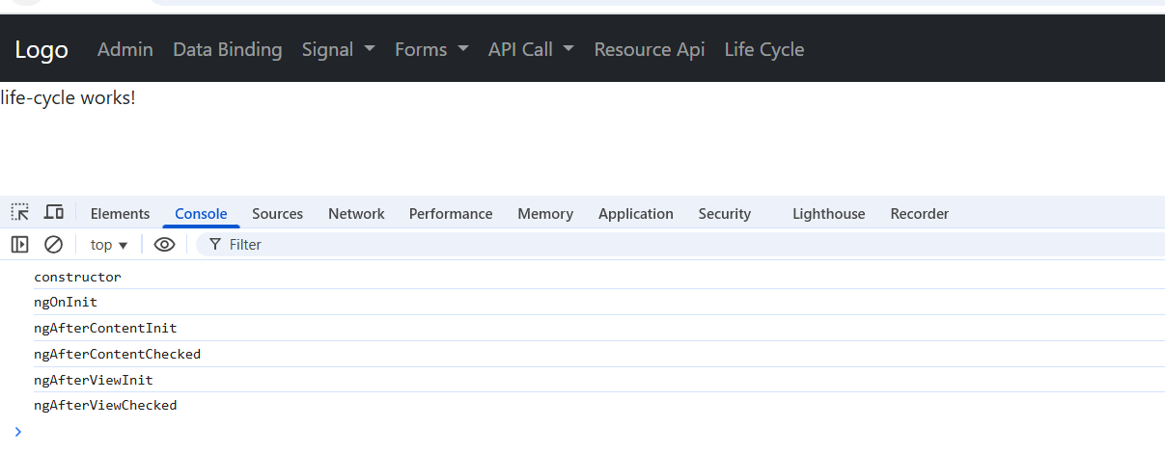

**What are Pipes ?**

Pipes are simple function by default provided by angular, Used to format the data before rendering on UI.

**Default Pipe in angular ?**

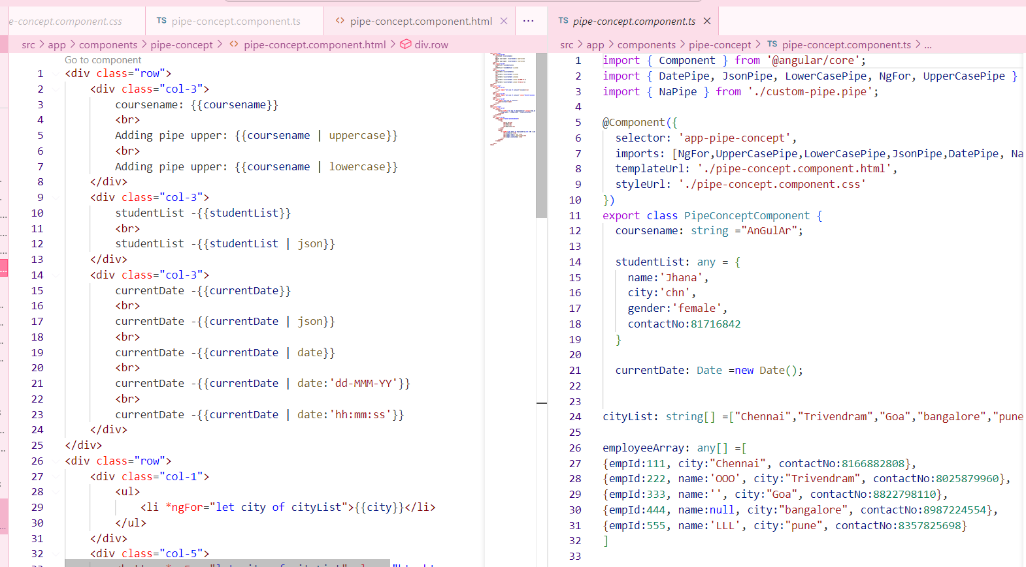

**How to Create Custom Pipe ?**

**What is @Input in angular?**

Is a decorator..

Sending of data from parent to child.

Example using a progress bar.

1.Using the selector name app-progress-bar, we can implement it in any component by adding it to the component's HTML file after importing it in the component's TypeScript file.

2. In order to pass data from parent to child we have to import input in child component.

**What is @Output() in angular ?**

Is a decorator

Get of data from child to parent.

**What is EventEmitter in angular?**

**How to Create Reusable component in angular ?**

**How to create interface ?**

**How to create class ?**

**When to use class or interface ?**

**How to Implement Login Page angular ?**

**What is Hard Code Login angular ?**

**How to Validate User With API angular ?**

**What is guard in angular ?**

**How to Create canActivate guard in angular ?**

**What is ViewChild ?**

**How to create viewChild for Element Reference ?**

**How to create viewChild for Component Reference ?**

**How to use signal with Forms.**

**Creating individual FormControl instead of creating Form.**

**Use of async Pipe with API call.**

**How to use resource api to make api calls.**

**use of Subject in Filter textbox**

**How to Use ngTemplate ?**

**How to Use ng-container ?**

**How to Use ngTemplateOutlet with ngTemplate ?**

**How to Use Interceptor?**

**How to Do JWT token Login ?**

**How to send token in headers in api ?**

**What is Dependency Injection?**

**Dependency Injection (DI)** is a fundamental concept in Angular. It is built into the Angular framework and allows classes with Angular decorators—such as components, directives, pipes, and injectables—to receive dependencies.

When a dependency is requested, the injector checks its registry for an existing instance. If the instance is not available, it creates a new one.

We can inject dependencies at the **app-root level**, making them accessible to all components. If a dependency needs to be accessible only to a specific component, we can use a **provider** within that component.

**CRUD**

**Lazy loading**

**$event is used to pass the data which is in the input to the typescript.**

**Event Emitter is used to discharge the events to the other components.**